Dynamic Freshness-Based Discounting Using Machine Learning

Introduction
Food spoilage and inventory waste are major problems in the retail industry. Perishable products such as dairy, bakery items, fruits, vegetables, and meat have limited shelf lives and must be sold within a specific time period. If these products remain unsold, retailers suffer financial losses.
To solve this problem, this project introduces a Dynamic Freshness-Based Discounting System using Machine Learning. The system predicts product freshness and recommends an optimal discount to encourage sales before the product expires.
This approach helps retailers improve inventory management, reduce waste, and increase revenue.
Problem Statement:
In shops and supermarkets, many food items get spoiled because they are not sold on time. This happens because it is difficult to know how fresh a product is and how much discount should be given.
This project solves this problem by using machine learning to check the freshness of products and suggest the right discount so that items can be sold before they expire.
Objective of the Project
The main objectives of this project are:
• Predict the freshness score of products.
• Recommend dynamic discount percentages based on product condition.
• Reduce product wastage.
• Improve inventory management and pricing strategies.
The system uses machine learning models for prediction.
Number of Models Trained
A total of 2 machine learning models were trained.
Model Number | Model Name | Purpose
Model 1 | Freshness Prediction Model | Predict current freshness score
Model 2 | Discount Prediction Model | Recommend optimal discount
Algorithms Used
The models were trained using the following algorithms:
• Random Forest Regressor
• Gradient Boosting Regressor
These algorithms are suitable for regression-based predictions and handle numerical data efficiently.
Dataset Description
The dataset contains information related to product storage conditions and shelf life.
Dataset Features
Feature | Description
temperature | Storage temperature
humidity | Storage humidity
storage_days | Number of days stored
freshness_score | Target variable for freshness
shelf_life | Remaining life of product
discount | Target variable for discount
These features help the model understand product conditions and predict outputs.
Sample Input &Sample output
Step 1: Freshness Prediction
Sample Input
Feature | Value
Product Category | Dairy
Days Since Arrival | 7
Storage Type | fridge
Storage Condition | good
Packaging Type | sealed
Display Type | fridge
Is Damaged | no
Weather Condition | normal
Product Sensitivity | high
Demand Level | high

Sample Output
- Predicted Freshness Score: 52.7%
- Status: Medium
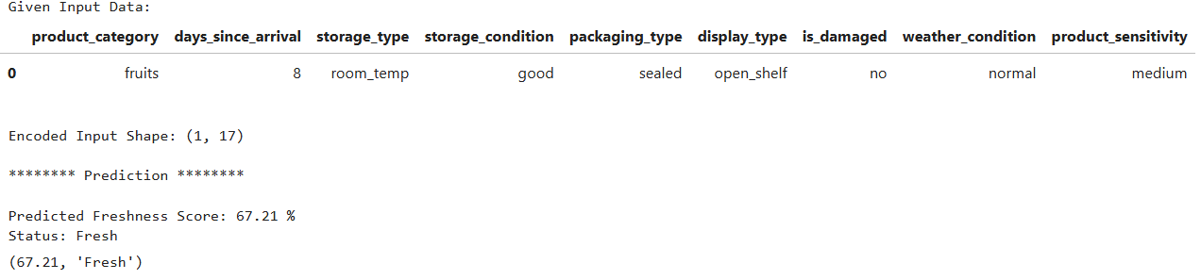
Step 2: Discount Prediction
The predicted freshness score from Step 1 is used as input for the discount model.

Sample Input
Feature | Value
Product Category | Dairy
Freshness Score | 0.527
Days Since Arrival | 7
Days to Expiry | 2
Original Price | 80
Cost Price | 60
Current Stock | 50
Daily Sales | 10
Demand Level | high
Season | normal

Sample Output
- Recommended Discount Percentage: 18.6%
- Final Price After Discount: ₹65.12
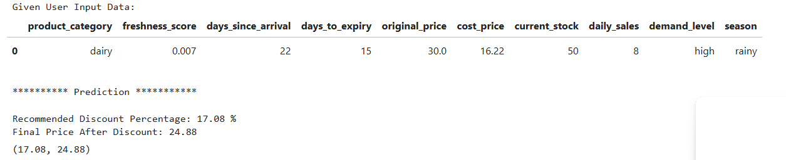
Model Training Process
The models were trained using the following steps:
- Data preprocessing and cleaning
- Feature selection
- Splitting dataset into training and testing sets
- Training machine learning models
- Evaluating models
- Saving models using joblib
requirements.txt
Create a file called requirements.txt
pandas==2.2.2
numpy==1.26.4
scikit-learn==1.4.2
joblib==1.3.2
Pickle Files
Include these trained models:
• freshness_model.pkl
• discount_model.pkl
Conclusion
The Dynamic Freshness-Based Discounting System demonstrates how machine learning can improve retail inventory management. By predicting freshness and recommending discounts, the system helps businesses sell products before expiration.
This approach reduces food waste, improves profit margins, and enhances overall efficiency. Future improvements may include real-time data integration and deployment as a web application.

